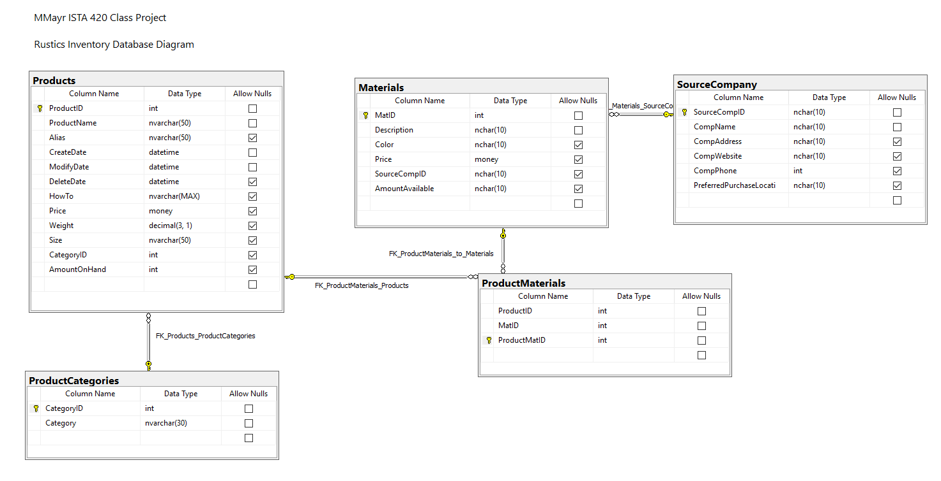

My Feedback:

* + Remove Plural naming
  + Remove DeleteDate
  + Rename Table
    - SourceCompany -> Supplier
  + Add Columns:
    - Materials.SafetyStock (reorder minimum)
      * Having a SS number allows you to maintain adequate inventory without having to stop what you’re doing to order more product. You can do it on-demand or in batch mode (nightly). Batch allows you potentially save shipping costs by using a single supplier and/or get a bulk discount.
    - Materials.Unit (size of unit)
      * Bulk pricing discounts and re-order measurement unit. Some suppliers may not be able to offer smaller Units and ultimately have a higher markup. Likewise; you may not move enough product to buy in larger Unit sizes and have excess Raw Materials Inventory
    - Product.version
      * Use for the GUI views, allows you to have a MasterProducts View as well as a CurrentProducts View used in conjunction with the ActiveFlag below which is just a bit flag; moreover, you have create date and modify date so there’s no need for delete date (redundant)
    - Product.ActiveFlag
      * If you align your Sales with Products over time, you can analyze if a product may have sold better. Maybe to save cost, you removed a feature and it doesn’t sell as well. The Active flag with the create and change dates aligned to sales let’s you determine correlation with other factors such as your BOM (ProductMaterials). Keep in mind, if you’re adding a feature to your product the you’ll want to be able to clone an existing product and then remove or add raw materials to it.
    - Product LeadTime
      * You can’t sell a product that doesn’t exist yet (you could but it creates unhappy customers). You’ll eventually use the information in this database to analyze which products are cash cows and which ones are dogs. A cash cow is something with low material costs, short lead times, good margin, and sells quickly. A dog should be retired or kept at a low inventory level (it could also be cyclic but that’s later).
      * When planning or forecasting this will also be important for the manufacturing process.
  + Change Columns:
    - Materials.Price ->Materials.UnitPrice
      * So you can align raw materials to BOM and cost to produce properly.